Name: Score:
Write the correct prepositions.
- 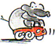 The elephant is __________________ the car.
- 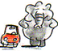The elephant is _________________ the car.
- 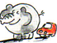The elephant is _____________________ the car.
- The elephant is _________________ the car.
- 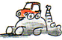 The elephant is ___________________ the car.
- 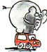The elephant is ______________ the car.
Directions: Use prepositions of place (in, on, under, next to, in front of, behind) to answer the following questions:
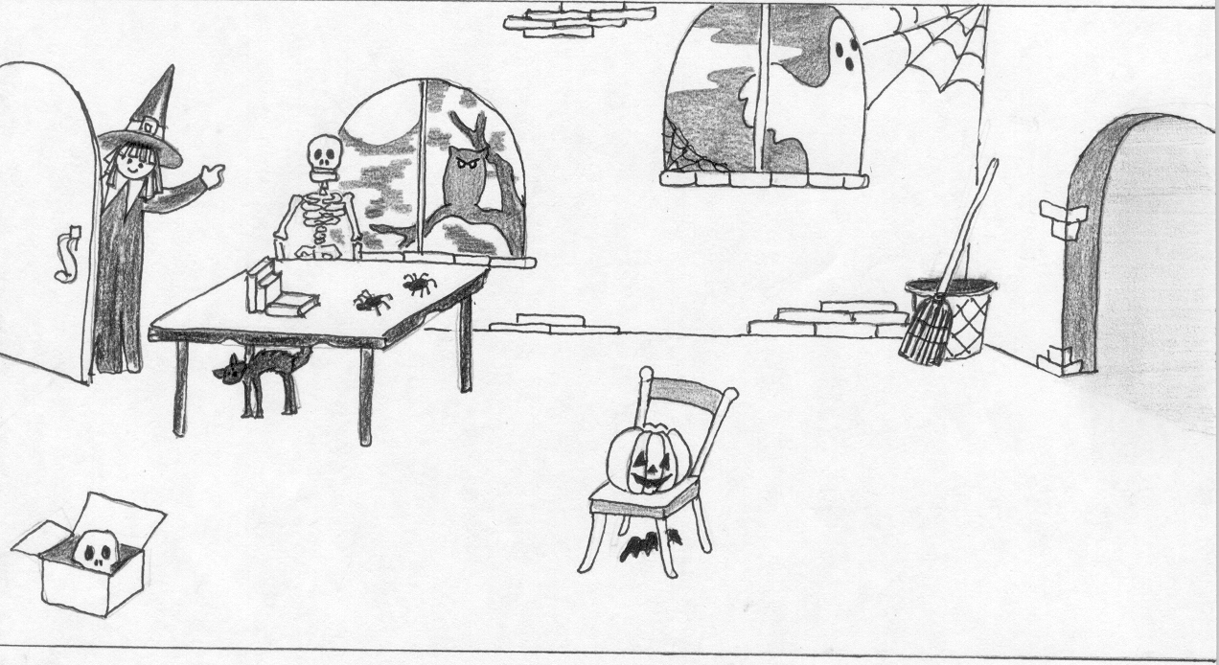

1.-Where is the Ghost? ___________________________________________________
2.- Where is the pumpkin? ________________________________________________
3.- Where is the Bat? ____________________________________________________
4.- Where is the witch? ___________________________________________________
5.- Where is the broom? _________________________________________________
6.- Where are the books? _________________________________________________
7.- Where is the skull? ___________________________________________________
8.- Where are the spiders? ________________________________________________
9.- Where is the black cat? _______________________________________________

