Christmas Maze

**reindeer**

**farmer**

**chimney**

**Tree ball**

**basketball**

**leaves**

**candle**

**bell**

**singers**

**trousers**

**stocking**

**elephant**

**gingerbread**

**Decoration b**

**snowman**

**hospital**

**sleigh**

**Santa**

**library**

**computer**

**notebook**

**candy cane**

**armchair**

**wardrobe**

**fifty**

**summer**

**gorilla**

**nurse**

**elf**

**present**



**Help Santa find his way through the maze.**

**Follow and circle Christmas words.**

**START**



**Look at the pictures and write the correct words.**

**FINISH**







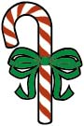

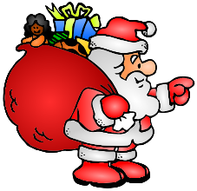

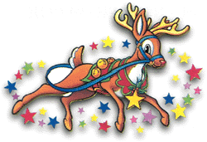



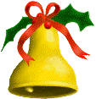

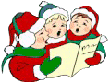

**Answer key:** Remind your students that they can go left, right, up or down, but not diagonally.

**reindeer**

**farmer**

**chimney**

**ornament**

**basketball**

**holly**

**candle**

**bell**

**carolers**

**trousers**

**stocking**

**elephant**

**gingerbread**

**decoration**

**snowman**

**hospital**

**sleigh**

**Santa**

**library**

**computer**

**notebook**

**candy cane**

**armchair**

**wardrobe**

**fifty**

**summer**

**gorilla**

**nurse**

**elf**

**present**

**START**

**FINISH**