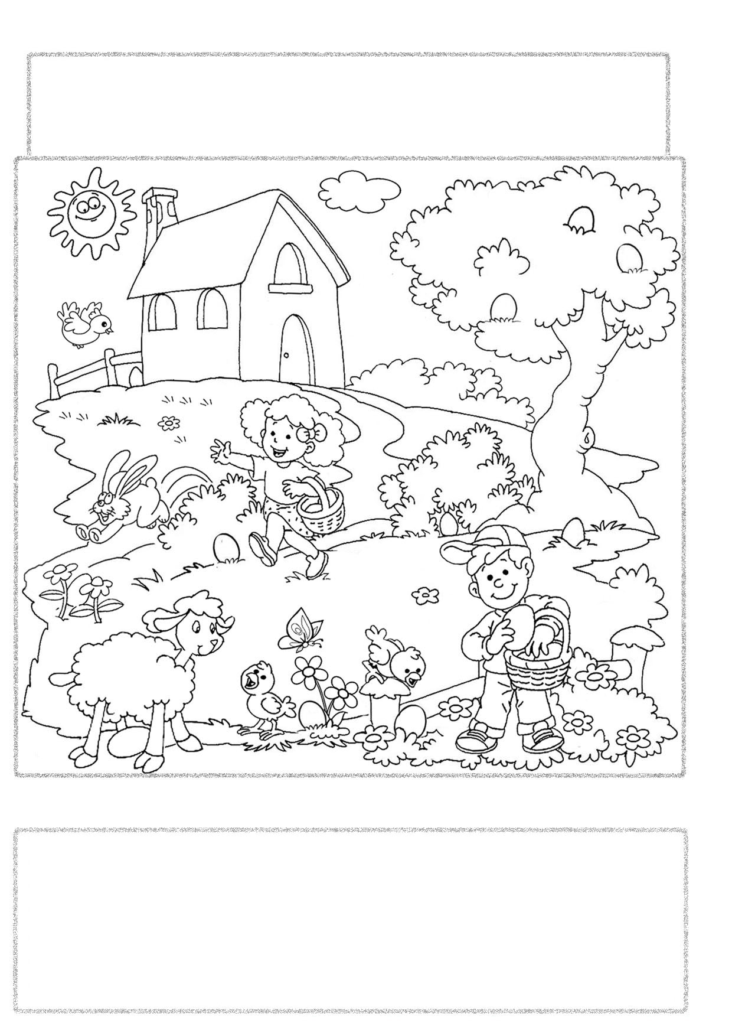
Easter is always on a Sunday between March and April. On Easter morning
British children play a very special treasure hunt called “Treasure Hunt Eggs".
The parents hide decorated eggs in their gardens and the children have to find them.
The winner is the boy or the girl who find the largest number of eggs.

Look at the picture and complete the sentences with the prepositions of place:
in - on - under - next to - in front of - behind - between.
There is an egg ………………….………… the boy. It's violet.
There is an egg ……………….…………… the flowers. It's red.
There is an egg ………………….………… the tree. It's purple.
There is an egg …………………….……… the sheep. It's light-blue.
There is an egg ……………………….…… the ears of the rabbit. It's green.
There is an egg ……………………….…… the bush. It's orange.
There are three eggs …………………… the tree. They are yellow, blue and pink.
Answer to the questions on your exercise book.
How many eggs can you find in the picture? How many children are there?
How many eggs has got the boy? How many flowers are there?
Can you find in the picture a bird? Is there a butterfly in the picture?

