Jobs. What do you do?

Word Bank
singer police officer mechanic doctor fireman farmer waitress football player teacher pilot baker nurse

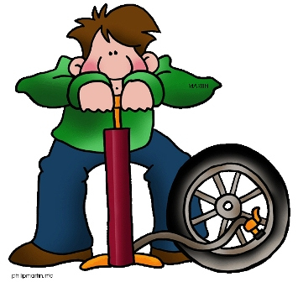  I'm a ________ | 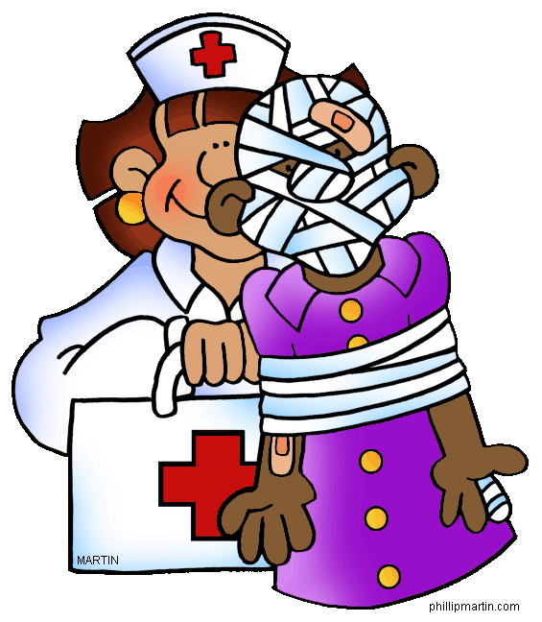  I'm a __________ |  |  |  |  |  |  | I'm a __________ |  |  |  |  |  |  |  | 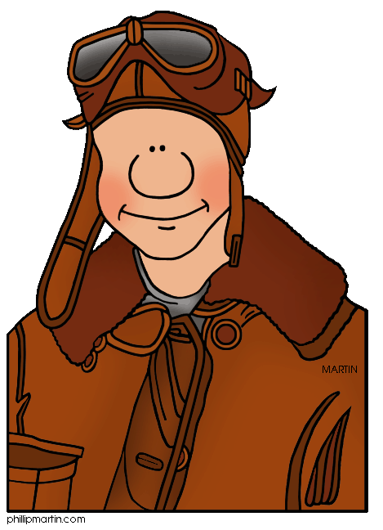  I'm a _______
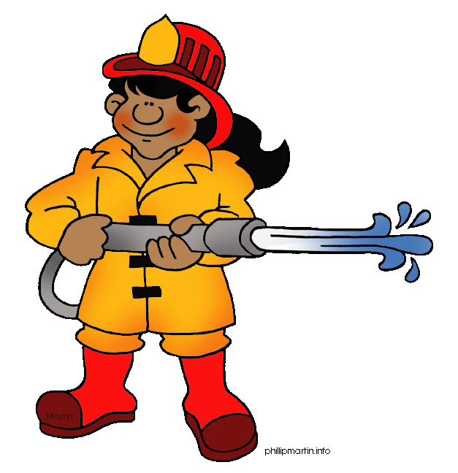  I'm a _________ | A | F | I | E | R | P | S |  | O | N | G | P | I | L | F | I'm a _______
 | B | E | C | H | E | N | I |  | G | L | E | O | S | S | O
 | A | K | S | I | N | G | E |  | R | O | I | L | M | D | O
 | K | T | E | H | C | R | A |  | N | C | P | I | T | E | T
 | E | N | S | M | E | C | H |  | A | N | I | C | I | R | B
 | R | A | I | R | S | T | E |  | A | C | H | E | R | E | A
 | K | E | T | P | F | A | R |  | M | E | R | O | A | L | L
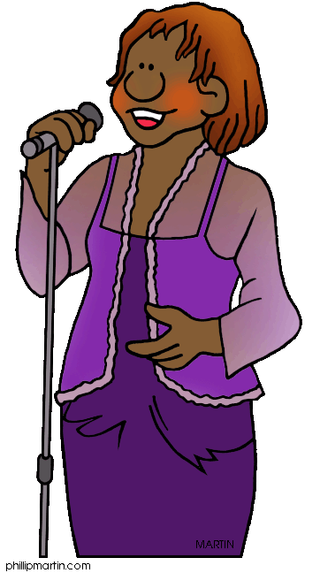  I'm a _________ | P | L | A | I | D | F | O |  | L | D | E | F | I | M | L | I'm a________
 | W | P | I | L | O | T | C |  | E | R | O | F | S | C | P
 | N | G | R | E | C | A | D |  | U | K | L | I | E | H | L
 | U | W | A | I | T | R | E |  | S | S | D | C | A | B | A
 | R | Y | U | R | O | V | N |  | O | K | A | E | T | K | Y
 | S | G | F | I | R | W | E |  | I | H | P | R | I | T | E
 | E | A | L | F | I | R | E |  | M | A | N | T | O | M | R
I'm a _________ | I'm a ____________ |  |  |  |  |  |  | 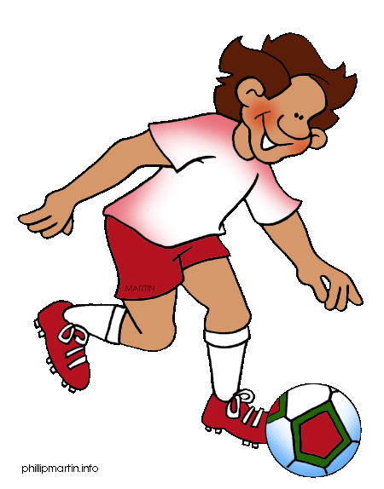  I'm a __________ |  |  |  |  |  |  |  | 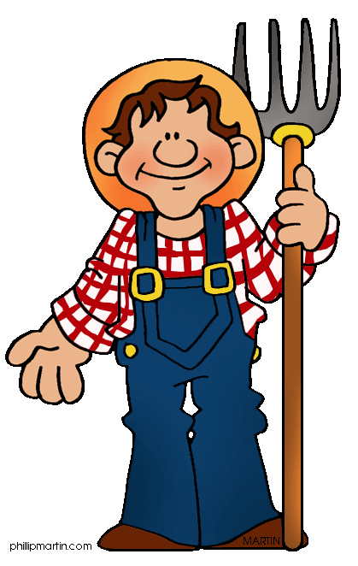  I'm a _______

