Where do you find these items?
Eating meals
Relaxing
Doing homework
Watching TV
Having a
shower
Sleeping
Cooking
1
2
3
4
5
6
7

Label the parts of the house. Match the activities with the parts of the house.

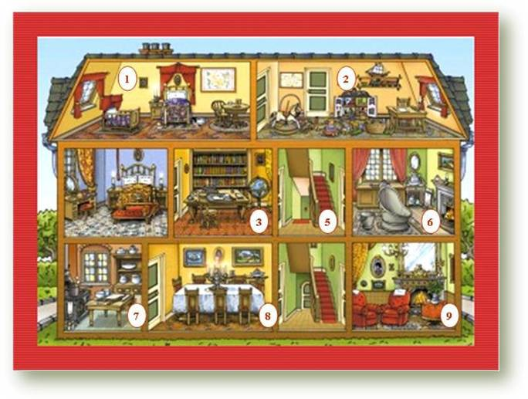
- Look at the picture and write the name of the rooms.
1.__________________ 2. __________________ 3. ___________________
4. __________________ 5. __________________ 6. __________________
7. __________________ 8. __________________ 9. __________________
- Answer the following questions about the picture.

- How many rooms are downstairs? ____________________________
- Is there a kitchen upstairs? _________________________________
- Is there a dining room downstairs? ___________________________
- Are there two bathrooms in the house? _______________________
- Is there a kitchen downstairs? ______________________________
- Where is the living room? __________________________________

