**SCHOOL**

Name: ______________________________ Class: ____

1. **Match.**

medium height

short

slim

fat

thin

tall

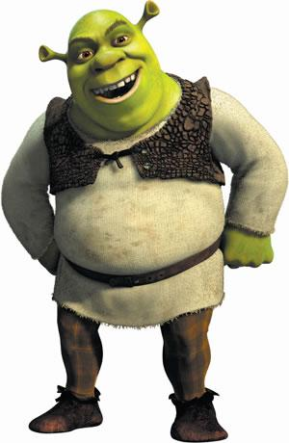

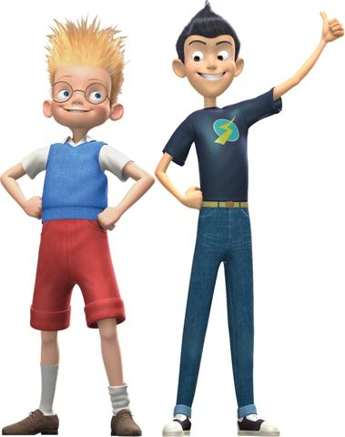

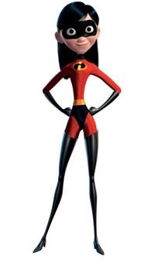

1. **Write sentences about the pictures**.
2. Shrek is______________ b) They____________________ c) She_____________

and __________________. __________________________ _________________

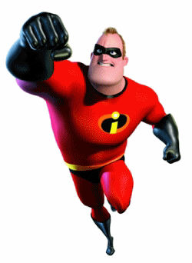

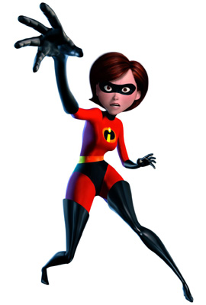

**3. Match**

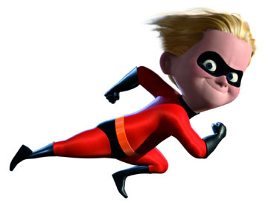



**4.**

**3.**

**2.**

**1.**

She is short and thin.

She is medium height and thin.

He is short and slim.

He is tall and fat.

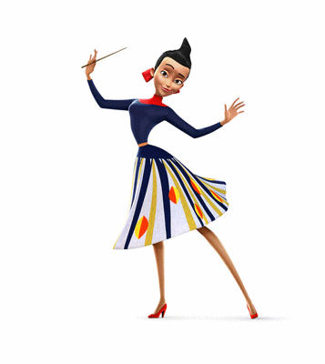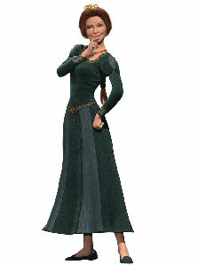**4. Describe the pictures.**

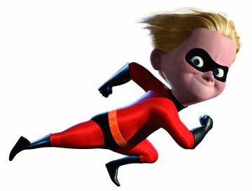

1. __________________ b) ____________________ c) ____________________

and _________________. and __________________ and___________________



**5. Ask and answer.**

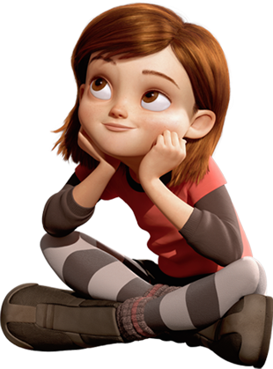

* 1. **Is she** fat? b) **Are they** short? c) **Is he** medium height?

_________________ _________________ _________________

 _________________ _________________ __________________

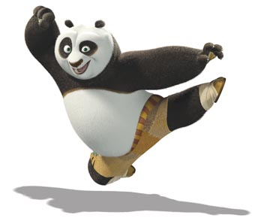



1. **Is he** short? e) **Is she** slim? f) **Is he** thin?

_________________ _________________ _____________________

______________________ _____________________ __________________________

1. **Colour the pictures.**

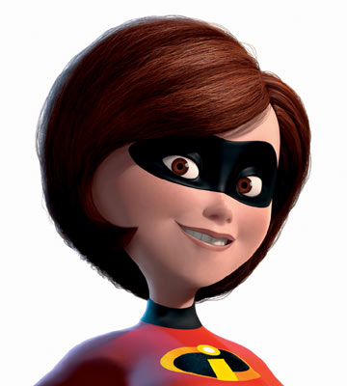

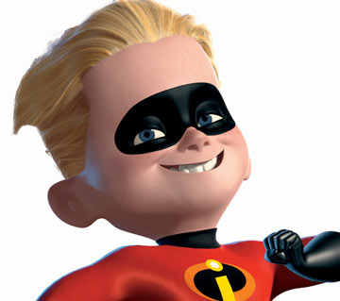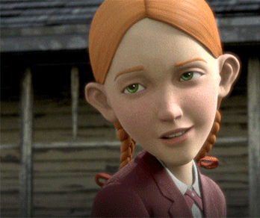

1. Blue eyes b) brown eyes c) green eyes

blond hair brown hair red hair

1. **Complete the sentences.**
2. He _____ _____ b) She ______ _____ c) ______ has got

_______ hair and _____ eyes . _______ hair and ______ eyes. green ______ and red ______.

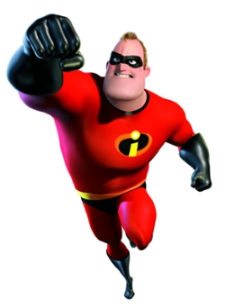

1. **Match.**



She is medium height and thin. She has got brown hair and brown eyes.

**2.**

**3.**

**1.**

He is tall and fat. He has got blond hair and green eyes.

He is short and slim. He has got blond hair and blue eyes.