Plants
Complete and match:
………………………….. are plants with a thick, hard stem called trunk. 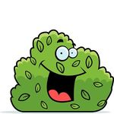
…………………………. are plants with a lot of stems and leaves. 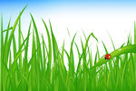
………………………. is a plant. It is thin and bendy. 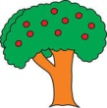
A tree is a plant. It has a thick hard stem called ………………….. 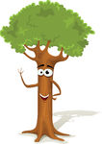
Trees have ……………………… 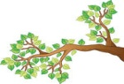 , …………………. 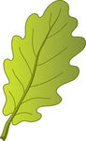 and twigs.

Write deciduous or evergreen.
...................................... trees lost their leaves in autumn. 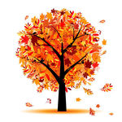
…………………………………. trees have green leaves all year. 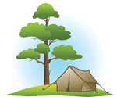
Answer:
What grows inside the fruit? ………………………………………………………………..
What grows from the seeds? ………………………………………………………………..
Draw a fruit with only one seed and other one with many seeds.

Number the sentences and match.
___ Plants grow. 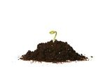
___ Plants are born. 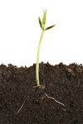
___ Plants die. 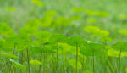
___ Plants reproduce. 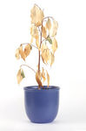
Answer:
What do plants need to grow well?
Plants need……………………………..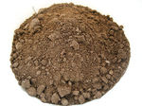 ……………………… 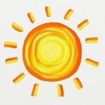 ……………………………… and ………………………. to grow well.
Complete the sentences:
leaves – stem – flowers – seeds - roots

The …………………….. absorb water and minerals.
The ……………………… supports the plant.
The ……………………….. absorb in air and sunlight.
The ……………………….. produces seeds.
The ……………………….. grow into new plants.

