Reptiles
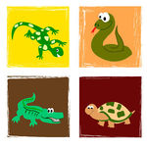
- Reptiles are vertebrate animals.
- Reptiles have scales 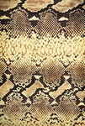 and some reptiles have a shell. 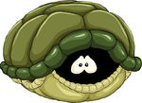
- Reptiles lay eggs. 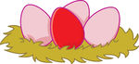
- Reptiles breathe with their lungs. 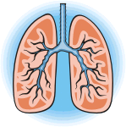
- Some reptiles have no legs and some have four legs. 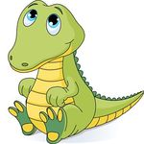
- Reptiles are cold-blooded.
Write the names of these reptiles.
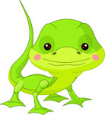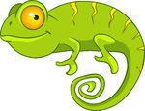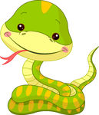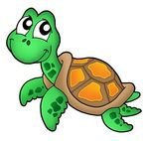
........................ ………………………. ……………… ………………. …………………..
Complete.
Reptiles are ……………………….. animals.
They have …………………….. and some have a ……………….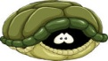
Reptiles lay ……………………
They breathe with their …………………..
Reptiles are ………………………………
Amphibians
- Amphibians live in water and on land. 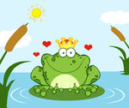
- They lay eggs in the water. 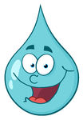
- Amphibians are vertebrates. 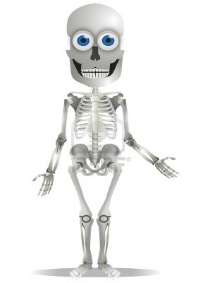
- Frogs, salamanders and toads are amphibians.
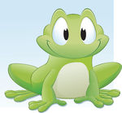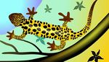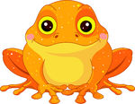
Complete
Amphibians live in ……………………………and on………………… 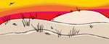
They lay………………… in the ………………….
Amphibians are …………………………………
Draw the life cycle of a frog.
Back legs grow
Tadpoles come out of the eggs.
Frogs lay eggs in the water

The frog comes out of the water.
Front legs grow and the tail disappears

