1.- Label the picture.

__________________________
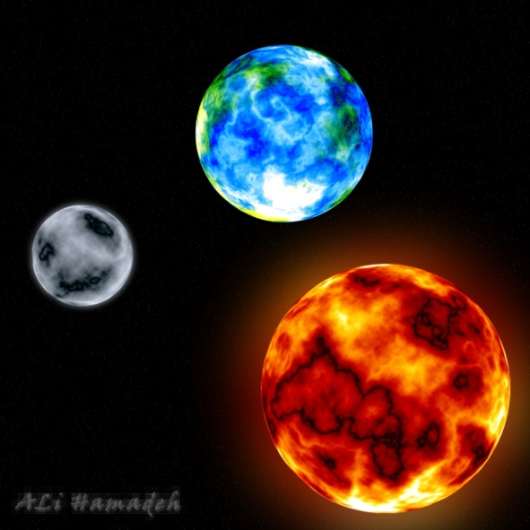

____________________________

________________________

2.- Complete the sentences with the words in the box.

star 8 Mercury light Moon heat gas

1 The Sun gives us ________________ and ________________.
2 The sun is a ________________ .
3 ________________ planets go around the Sun.
4 There closest planet to the Sun is ________________ .
5 The Sun is made up of ________________ .
6 The _________ orbitates around the planet Earth

3.- Label the picture.
sunrise midday night sunset

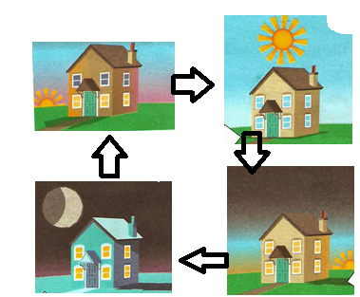
4.- Look for the planets
