SCIENCE NAME ____________________
VERTEBRATES REVISION

Vertebrate animals have a s_______________ made up of bones.
There are five groups of vertebrate animals.

- MAMMALS Most mammals live on l__________ and use their l_________ to move

around. There are also mammals that live in the s_______ and other animals that

have w________ to fly.

- How do mammals reproduce? They are ____________________

- How do mammals breathe? They breathe through _______________

- What is their external cover? They have __________ and _________ or _________

- Give 2 examples of land mammals. __________________, __________________

- Give 2 examples of marine mammals. __________________, __________________

- Give 2 examples of primates. __________________, __________________

- Give 1 example of a flying mammal. __________________

- REPTILES Reptiles live on the l________ and some can live in w________ too.

- How do reptiles reproduce? _____________________________________________

- How do reptiles breathe? _______________________________________________

- Can you write the names of the external cover of these reptiles?

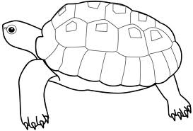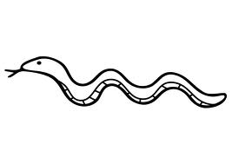
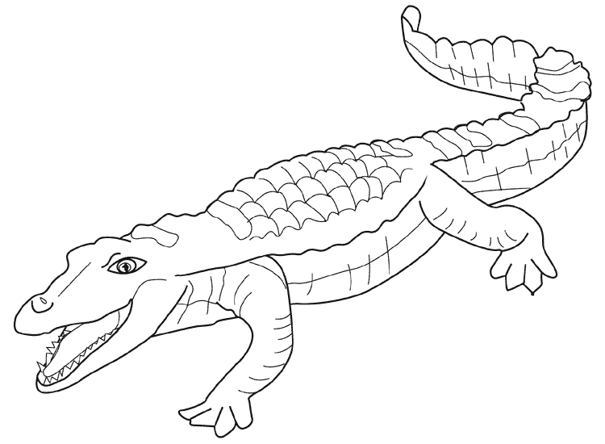

- Give 3 other examples of reptiles. ____________, ____________, ___________

- BIRDS Birds have a b________ and their skin is covered with f____________.

They have two w____________ to fly

- How do birds reproduce? __________________________________________________

- How do birds breathe? ____________________________________________________

- Can you think of a bird that cannot fly? ______________________

- Give 3 more examples of birds. ______________, _____________, _____________

- FISH Fish are a_________________; this means that they live in water.

- Can you label the parts of this fish?

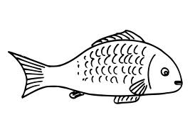

- What do fish use to breathe in oxygen? ____________________________________

- How do fish reproduce? ________________________________________________

- AMPHIBIANS Amphibians are covered with s__________

- How do amphibians reproduce? __________________________________________

- How do amphibians breathe? Name 2 ways. ________________________________

- A tadpole is a baby frog. How do tadpoles breathe? __________________________

Categorise these vertebrates.

hake salamander toad bear shark flamingo tortoise rat
crocodile parrot snake whale penguin iguana kangaroo
MAMMALS | REPTILES | BIRDS | FISH | AMPHIBIANS

